**1.Pnar-GFP**

Pnar  B0034 GFP B0015

**procedure expected results**

Construct a recombinant expression vector pWB980-DB-Pnar-GFP.

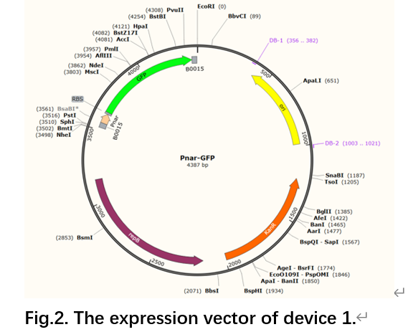

Construct and screen recombinant engineered bacteria.

Characterization experiment：the experimental group is cultured in an anaerobic environment, and the negative control group is cultured in an aerobic environment.

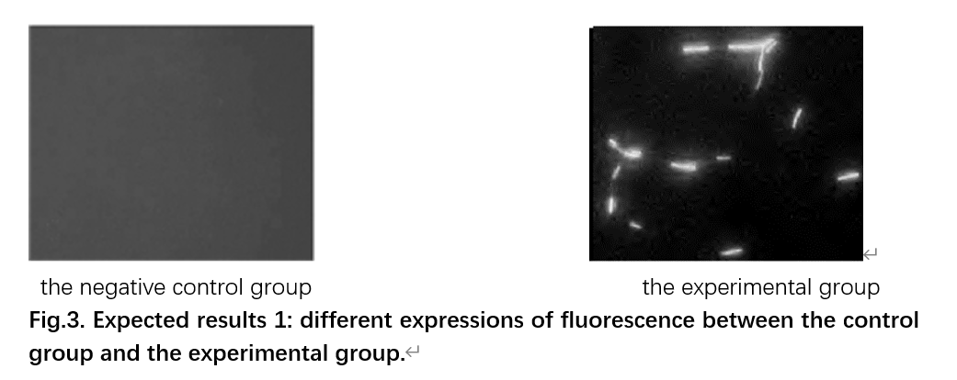

Use the fluorescence microscope to observe the presence of fluorescence.

**2.P**nar**-phy(yCD)**

Pnar B0034 phy(ycD) B0015

**procedure expected results**

Construct a recombinant expression vector pWB980-DB-Pnar-phy(ycD).

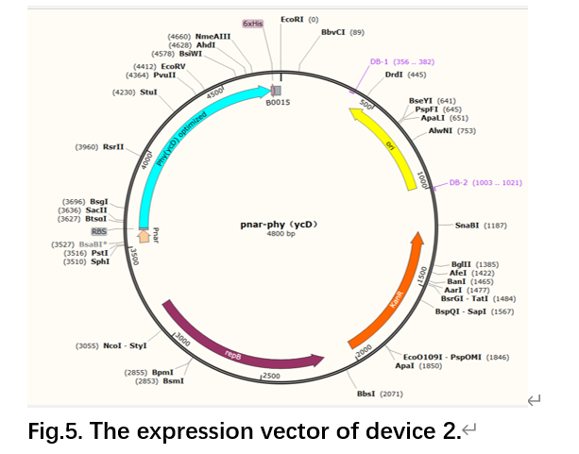

Construct and screen recombinant engineered bacteria.

Phytase expression and purification

The molecular weight that can be determined by SDS-PAGE analysis of the expressed enzyme is 45 KD, and the protein can be determined to be phytase by Western blot.

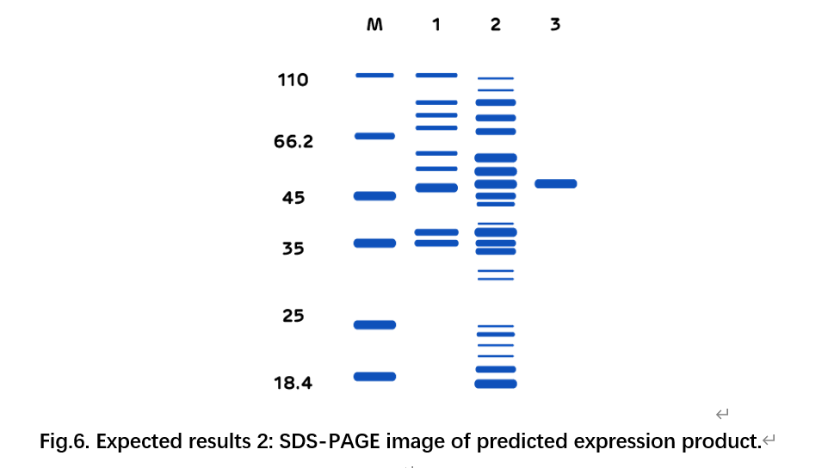

The control group: recombinant *Bacillus subtilis* are cultured in an aerobic condition

The experimental group: recombinant *Bacillus subtilis* are cultured in an anaerobic condition

SDS-PAGE gel electrophoresis

Western blot

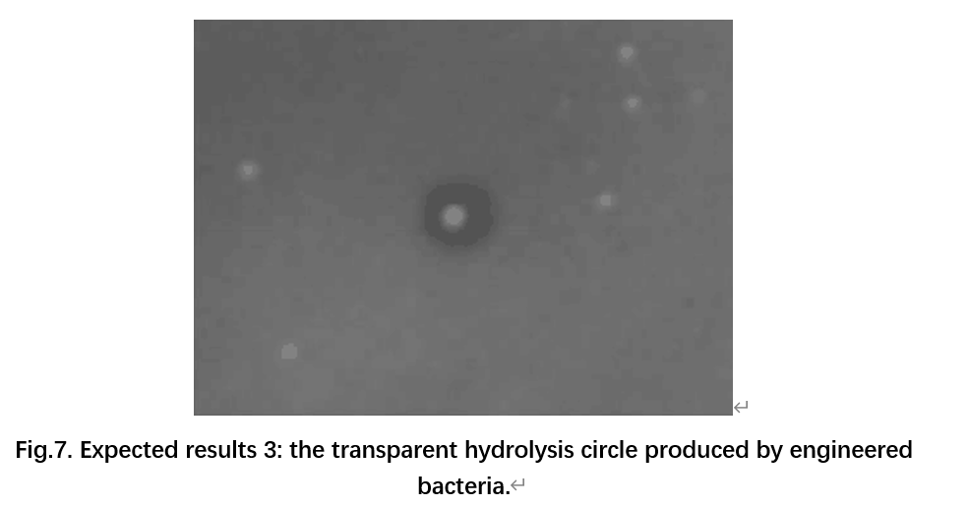

BCA assay

Verification of the effect of phytase on phosphate hydrolysis.

Verification of the effect of phytase to dissolve phosphorus and solid lead.

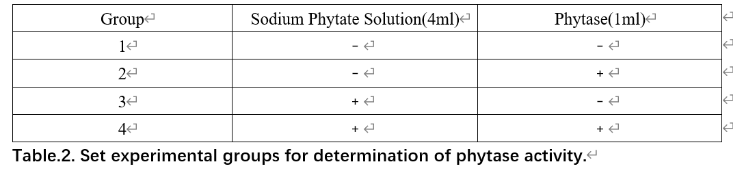

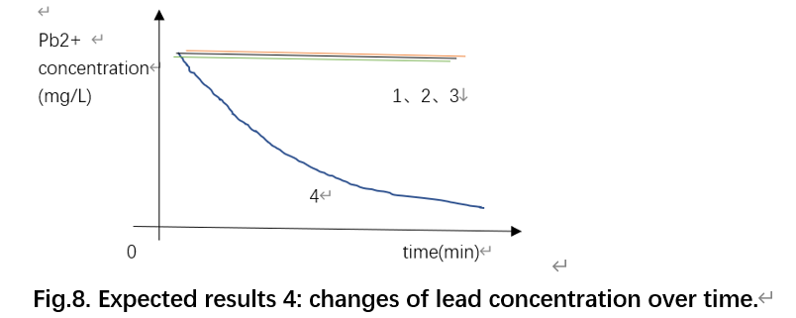

In each group of experiments, 15ml of 230mg/L PbCl2 is added to react for 1h, and then lead content in reaction system is determined by dithizone colorimetry.

**3．P**nar**-CⅠ-P**CⅠ**-GFP**

Pnar  B0034 CI B0015 PcI  B0034 GFP B0015

**procedure expected results**

Construct a expression vector Pnar-CI-PcI-GFP.

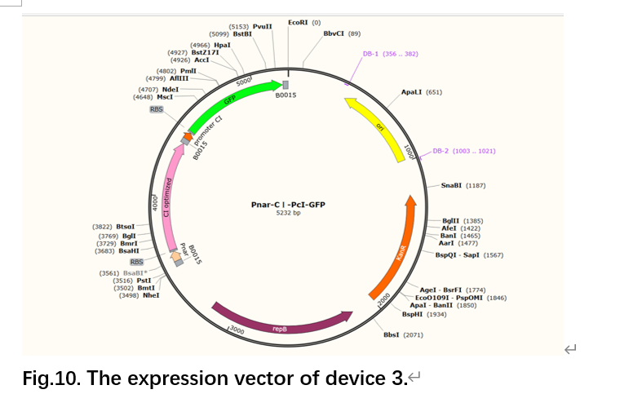

Construct and screen recombinant engineered bacteria.

.

Characterization experiment：Culture engineered bacteria which have been transformed successfully for 6 hours, the experimental group is cultured in an anaerobic environment, and the negative control group is cultured in an aerobic environment.

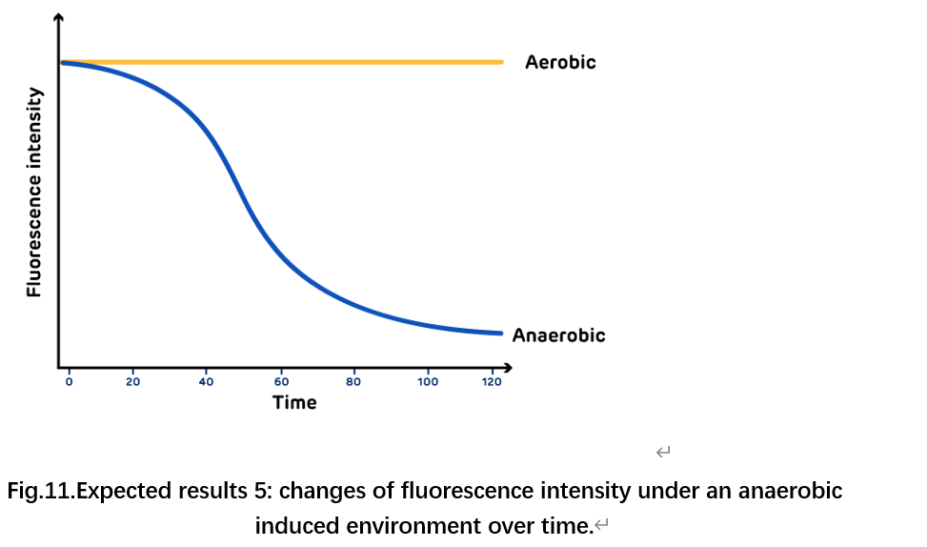

Use the multifunctional enzyme marker to observe the presence of fluorescence.

**4.P**liaG**- trigger RNA-P**CⅠ**-switch RNA-GFP**

PliaG trigger RNA B0015 PcI  switch RNA-GFP B0015

**procedure expected results**

Construct a expression vector PliaG- trigger RNA-PCⅠ-switch RNA-GFP.

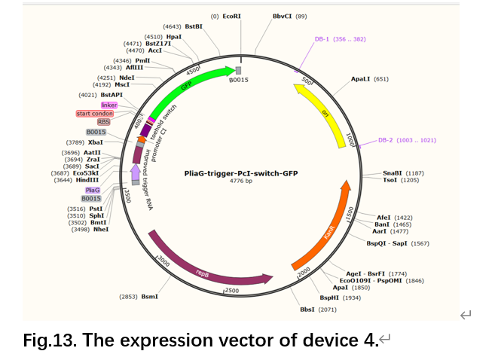

Construct and screen recombinant engineered bacteria.

Characterization experiment

The control group: LB liquid medium without kanamycin, inoculate the wild type of *Bacillus subtilis*

The experimental group: LB liquid medium with kanamycin, inoculate the successfully transformed engineered bacteria

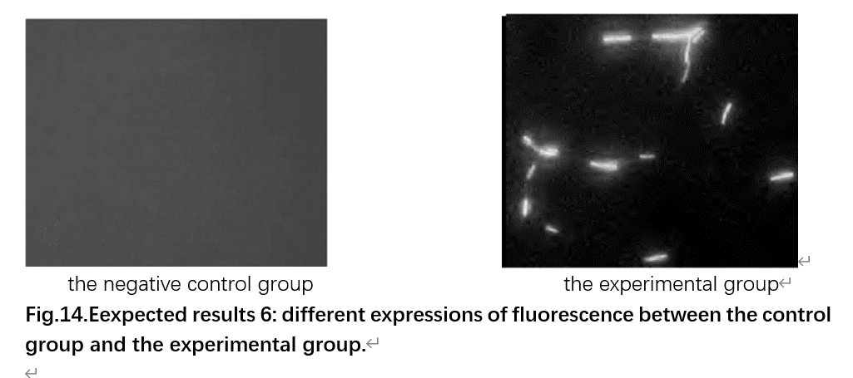

Use the fluorescence microscope to observe the presence of fluorescence.

**5.P**nar**-trigger RNA-P**CⅠ**-switch RNA-mazF**

Pnar trigger RNA B0015 PcI switch RNA-mazF B0015

**procedure expected results**

Construct the expression vector Pnar-trigger RNA-PCⅠ-switch RNA-mazF.

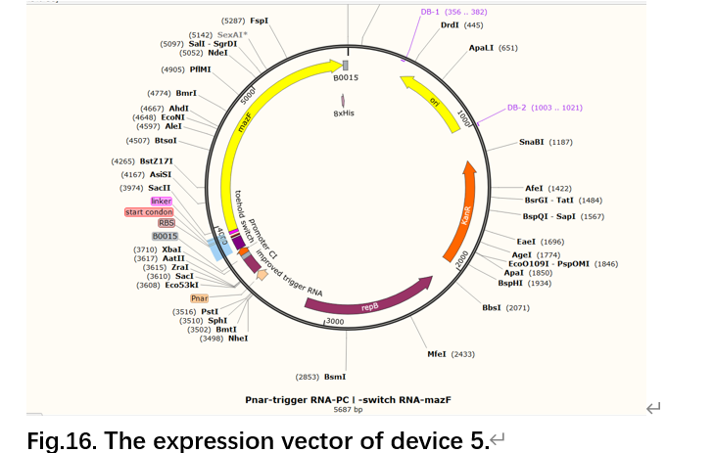

Construct and screen recombinant engineered bacteria.

Characterization experiment

Take 2 bottles of 50ml LB liquid medium with kanamycin, and inoculate the same amount of recombinant engineered bacteria.

Culture engineered bacteria which have been transformed successfully for 6 hours

The experimental group: culture in an anaerobic induced environment for 6 hours

The negative control group： culture in an aerobic environment for 6 hours

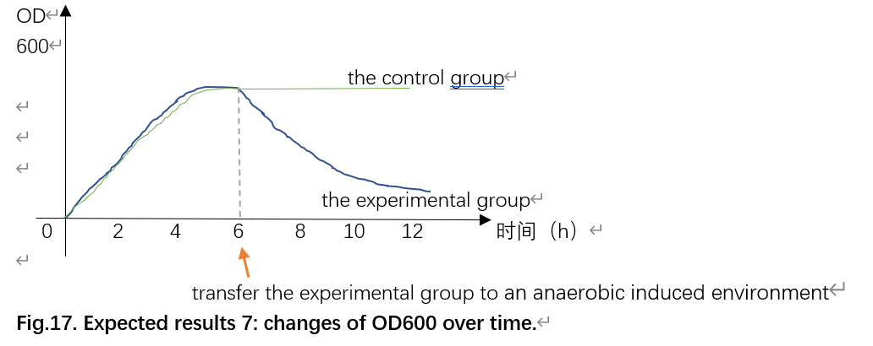

Measure OD600 value of bacteria liquid every 2 hours.

**6.P**liaG**-lacⅠ-P**grac**-CⅠ-P**CⅠ**-GFP**

PliaG B0034 lacI B0015 Pgrac  B0034 CI B0015

PcI B0034 GFP B0015

**procedure expected results**

Construct a expression vector PliaG-lacⅠ-Pgrac-CⅠ-PCⅠ-GFP.

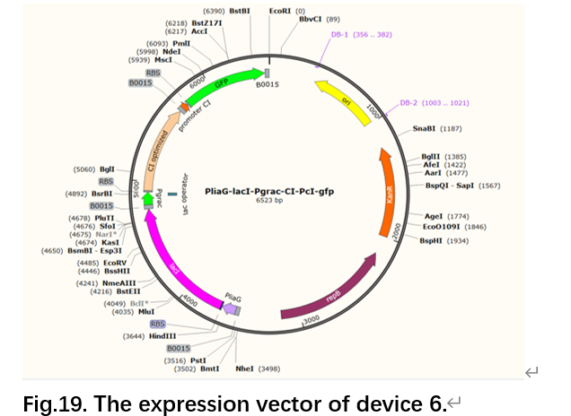

Construct and screen recombinant engineered bacteria.

.

Characterization experiment

Take 2 bottles of 50ml LB liquid medium with kanamycin, and inoculate the same amount of recombinant engineered bacteria.

After culturing for 3 hours, the experimental group is cultured with 1 mM IPTG at 37°C and 200 rpm for 2 hours while the control group is not added IPTG.

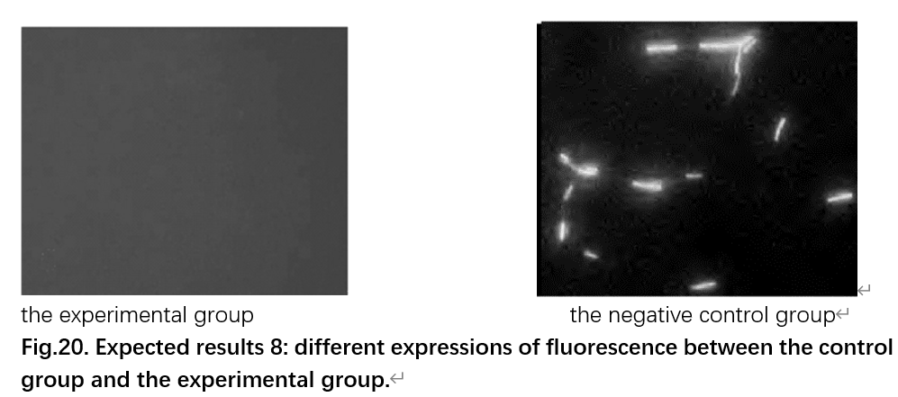

Use the fluorescence microscope to observe the presence of fluorescence.